National Statistics

School closures in response to COVID-19:
As of May 6, 2020, 48 states, 4 U.S. territories, and the District of Columbia have ordered or recommended school building closures for the rest of the academic year, affecting approximately 50.4 million public school students.

School closures due to coronavirus have impacted at least 124,000 U.S. public and private schools and affected at least 55.1 million students.

Data Source:
EdWeek Coronavirus and School Closures
https://www.edweek.org/ew/section/multimedia/map-coronavirus-and-school-closures.html

Regarding school districts and crisis preparedness plans that include responding to pandemic outbreaks, in 2016 approximately:
- 74% of school districts had crisis preparedness plans that included procedures for responding to pandemic outbreaks;
- 65% of districts required schools to include responding to pandemics in their preparedness plans; and
- 64% of districts had one or more district-level leadership group(s) that addressed the management of infectious diseases, like in pandemics.
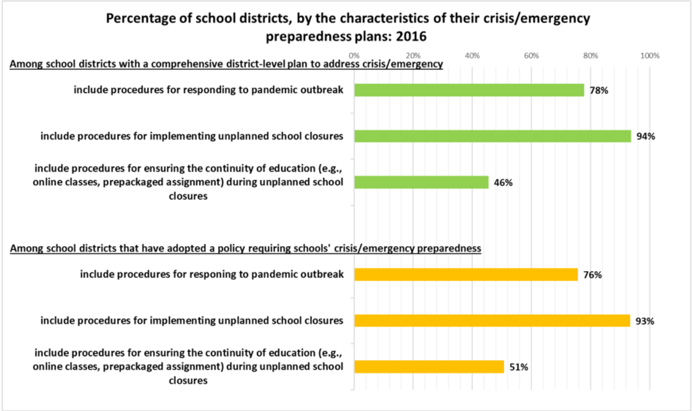

Among school districts that had leadership groups to address the management of infectious diseases, most included the following types of members in their teams:
- community members (85%),
- public safety agencies (65%),
- mental health/social service agencies (55%), and
- school board members (54%).

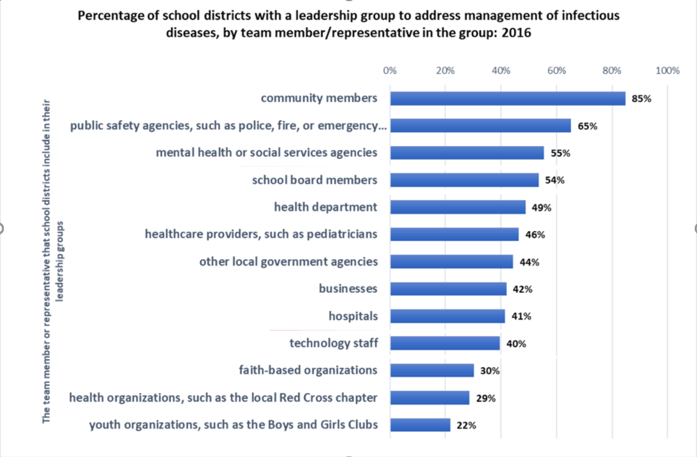

Data Sources and Images:
Centers for Disease Control and Prevention: School Health Policies and Practices Study (SHPPS) 2016
https://www.cdc.gov/healthyyouth/data/shpps/pdf/shpps-results_2016.pdf

National School Boards Association: CDC Data on Schools’ Response to Pandemics
https://www.nsba.org/Perspectives/2020/school-response-pandemic

Additional K-12 COVID-19 Resources

NSBA Responding to Coronavirus Resources
The National School Boards Association coronavirus page contains resources aimed at supporting public schools and education leaders with the most up to date information and resources.

NSBA Center for Safe Schools Webinar: Navigating Virtual Education — with Calm, Connectedness and Compassion
Hosted by NSBA’s Center for Safe Schools in collaboration with the Attachment & Trauma Network, this discussion focuses on the impact of school closures and the new "normal" this is creating for families and educators alike. This discussion addresses the impact of the COVID-19 pandemic on schools and families and how we can help children and families, especially those with adverse childhood experiences (ACEs), navigate this new environment. Read an overview of the discussion and learn more about the presenters.

NSBA COSA Families First Coronavirus Response Act FAQ
How does the Families First Coronavirus Response Act impact student meals and school employee leave? COSA, a program of NSBA, has answered common questions school districts might have regarding relief for schools.

John Hopkins University Coronavirus Resource Center
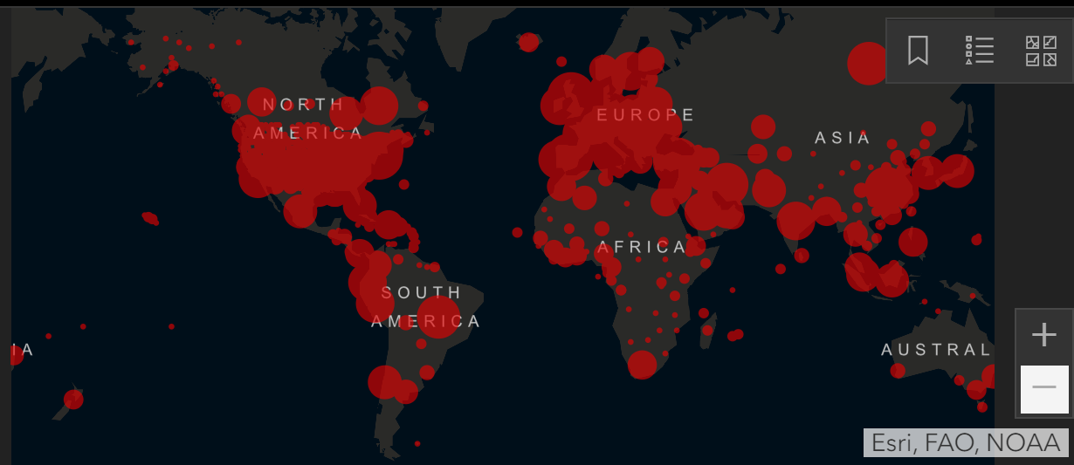
John Hopkins University Coronavirus Resource Center and Map provide up to date information on the number of confirmed cases, deaths and recoveries by country, state and county.

IHME 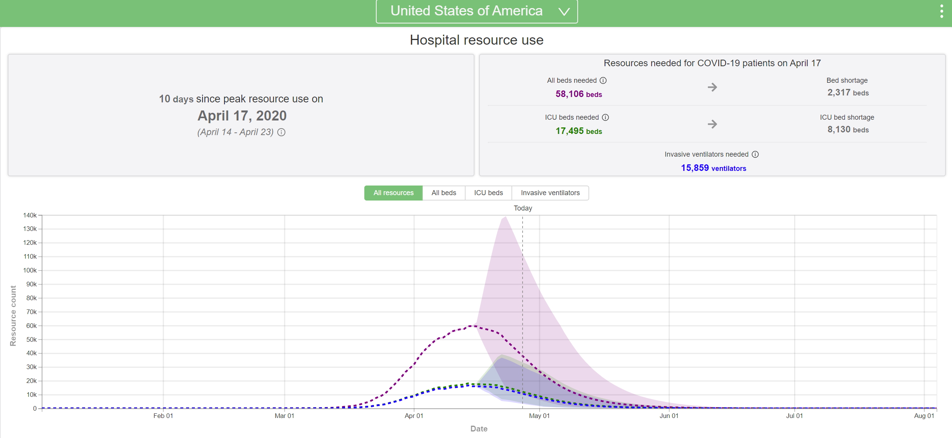
The Institute for Heath Metrics and Evaluation’s COVID-19 forecasting model shows projected impacts on hospital bed-days, ICU-days, ventilator days, and deaths by US state over the next four months.

ATN Trauma-Informed Resources Available During COVID-19 Quarantine
The Attachment & Trauma Network provides resources and tips for parent and families with children who have been impacted by trauma and by attachment disorders during the coronavirus outbreak.

BuyBoard Facts and Resources
Compiled by a national purchasing cooperative, this facts and resource sheet includes recommendations to minimize spread of respiratory illnesses, cleaning and disinfecting procedures, and a directory of resources including sample guidance from county and state health agencies.

CDC Data on Schools' Response to Pandemics
The Center for Public Education analyzes the presence of pandemic procedures in school districts’ crisis/emergency preparedness plans and offers helpful suggestions for implementing long-term strategies.

Centers for Disease Control and Prevention
The Centers for Disease Control and Prevention's coronavirus page includes an overview of what you should know about the disease, situation updates, and information tailored to different industries, including communities, schools, and businesses.

COVID-19: Preparing for Widespread Illness in Your Community: A Legal Guide for School Leaders
A companion guide to Fostering Safer Schools and made in collaboration with the National Association of School Nurses, this legal guide explores the federally identified risks associated with COVID-19 and provides a checklist of issues school leaders should consider.

Department of Education
The U.S. Department of Education has compiled links and resources for schools and school personnel, as well as best practices for preventing the spread of disease.

Making the Transition to Virtual Classrooms
From the Education Development Center, this blog post shares useful online learning strategies. The Education Development Center has also compiled its own resource page for educators and caregivers covering topics from student mental health to supporting STEM learning at home.

Mental Health America
For the general public, the mental health effects of COVID-19 are as important to address as the physical health effects. To aid individuals and communities during this time, MHA has compiled a range of resources and information.

World Health Organization
A detailed Q&A from the World Health Organization on the coronavirus.

