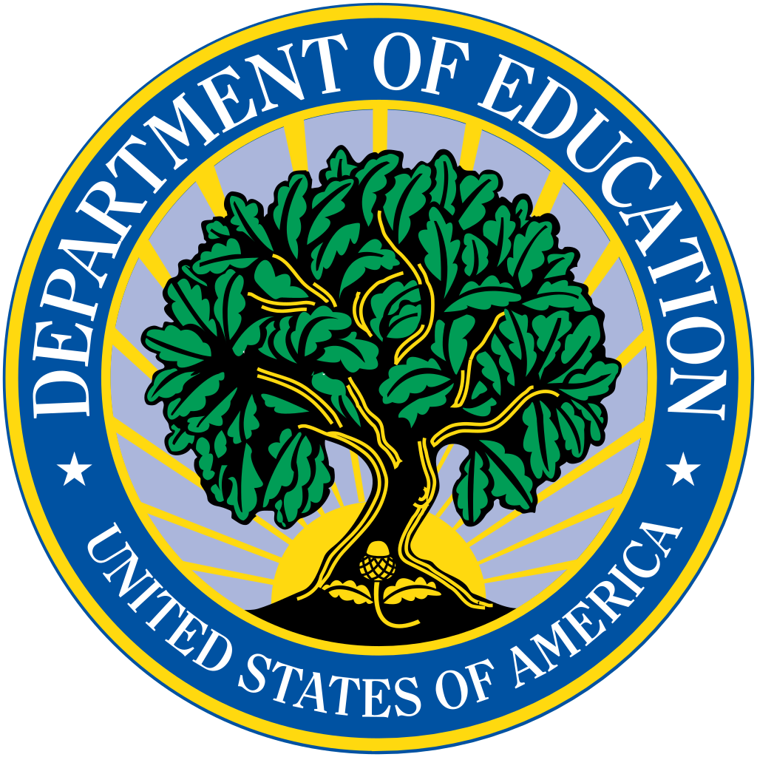

Webinar Announcement

Identifying and Supporting Students Affected by Human Trafficking
A national webinar hosted by

the U.S. Department of Education

Thursday, January 30, 2020
3:00 – 4:15 p.m. Eastern Time
REGISTER FOR THIS WEBINAR
https://zoom.us/webinar/register/WN_OyZbrypGS2eORa5omP81dA

The year 2020 marks the 20th anniversary of the passage of the Trafficking Victims Protection Act. In recognition of this significant milestone, the U.S. Department of Education is conducting this webinar, the first in a series to be conducted in 2020, to address the growing response of America’s schools to child trafficking. The event will include discussion of strategies being used to support students impacted by trafficking.

The event is designed to provide building-level administrators, teachers, and specialized instructional support personnel with information on how they can effectively identify, and support students impacted by trafficking activity.

The webinar will feature a variety of perspectives, including:
- A representative of a lead federal agency will provide the national context of human trafficking;
- A representative from the U.S. Department of Education will describe what the Department is doing to address this issue;
- A national subject matter expert will explain what’s known & what’s working to address human trafficking;
- A human trafficking specialist from a school district will describe what it has been doing to address human trafficking;
- A survivor will share why this work matters; and
- Speakers will answer your questions.

To register for this webinar, go to https://zoom.us/webinar/register/WN_OyZbrypGS2eORa5omP81dA.
For more information on how to address trafficking, go to https://www.state.gov/policy-issues/human-trafficking/ and https://www.acf.hhs.gov/otip.

For questions regarding the content presented in the webinar, email ncssle@air.org.

